**Triggers and Procedures**

**Objective**

To automate database actions using triggers and stored procedures for efficient and maintainable student record management.

**Database Setup**

Database Creation

CREATE DATABASE student_management;

USE student_management;

**Explanation:**  
 Creates a new database named student_management and sets it as the active context for all subsequent operations.

Table Creation

1.students Table

CREATE TABLE students ( id INT AUTO_INCREMENT PRIMARY KEY, name VARCHAR(100), score INT, grade VARCHAR(10) );

**Explanation:**  
 Stores student details. id is the unique identifier, score represents performance, and grade reflects academic standing.

**Output:**

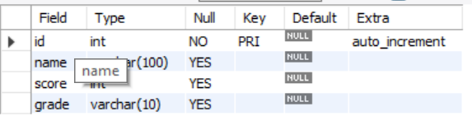

2. student_update_log Table

CREATE TABLE student_update_log ( log_id INT AUTO_INCREMENT PRIMARY KEY, student_id INT, old_name VARCHAR(100), new_name VARCHAR(100), old_grade VARCHAR(10), new_grade VARCHAR(10), updated_at TIMESTAMP DEFAULT CURRENT_TIMESTAMP );

**Explanation:**  
 Captures audit logs whenever a student record is updated. It stores both old and new values for name and grade, along with a timestamp.

**Output:**

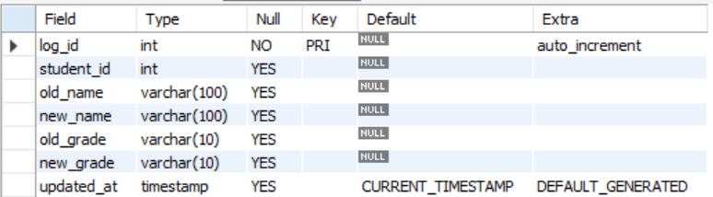

Sample Data Insertion

INSERT INTO students (name, score, grade) VALUES ('Alice', 92, 'B'), ('Bob', 76, 'C'), ('Charlie', 65, 'D'), ('Diana', 88, 'B'), ('Ethan', 54, 'D');

**Explanation:**  
 Populates the students table with sample data for testing triggers and procedures.

**Output:**

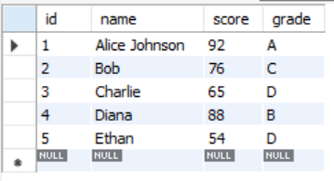

**Trigger Definition**

DELIMITER //

CREATE TRIGGER log_student_update

AFTER UPDATE ON students

FOR EACH ROW

BEGIN

INSERT INTO student_update_log ( student_id, old_name, new_name, old_grade, new_grade ) VALUES ( OLD.id, OLD.name, NEW.name, OLD.grade, NEW.grade );

END; //

DELIMITER ;

**Explanation:**  
 This trigger activates automatically after any update to the students table. It logs the previous and new values into student_update_log.

**Procedure Definition**

DELIMITER //

CREATE PROCEDURE update_student_grades( IN min_score INT, IN max_score INT, IN new_grade VARCHAR(10) ) BEGIN

UPDATE students SET grade = new_grade WHERE score BETWEEN min_score AND max_score;

END; //

DELIMITER ;

**Explanation:**  
 Encapsulates reusable logic to update student grades based on score ranges. Accepts parameters for flexible grading criteria.

**Sample Executions**

**Trigger Test**

UPDATE students SET name = 'Alice Johnson', grade = 'A' WHERE name = 'Alice';

**Output:**

**Student table**

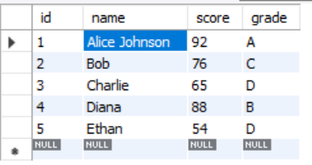

Log table

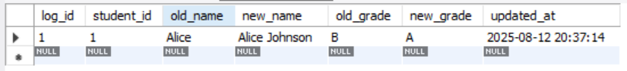

**Output Explanation:**  
 The student_update_log table should contain a new entry showing:

student_id of Alice

old_name as "Alice"

new_name as "Alice Johnson"

old_grade as "B"

new_grade as "A"

This confirms the trigger is functioning correctly.

**Procedure Test**

CALL update_student_grades(85, 100, 'A');

CALL update_student_grades(70, 84, 'B');

CALL update_student_grades(50, 69, 'C');

**Output:**

**Student table**

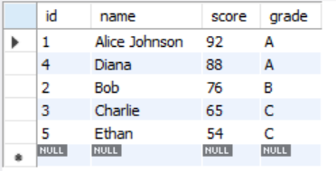

**Log table**

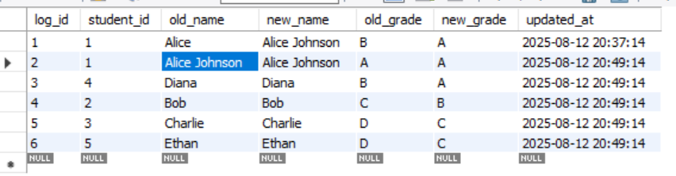

**Output Explanation:**  
 The students table should reflect updated grades:

Scores ≥ 85 → Grade 'A'

Scores between 70–84 → Grade 'B'

Scores between 50–69 → Grade 'C'

This confirms the procedure correctly applied the grading logic.

**Summary of Findings**

The implementation successfully automated student record updates and grading logic. The trigger accurately logged changes to student names and grades in the audit table, ensuring traceability. The stored procedure provided a flexible and reusable way to update grades based on performance criteria, simplifying bulk operations. Both mechanisms were validated through sample executions and produced the expected results. This approach enhances database maintainability and ensures consistent data handling.